2010 Unified Broad Equity ETF Timing

V1.1

Dan Micsa, dan@dmicsa.com, www.dmicsa.com

The aim of this paper to present the results of a unified market timing system that performs decent on broad equitiy ETFs. I chosed to limit the research to {SPY, IWM, EWZ} ETFs for [1/1/2002-1/1/2010] period in time.
First column is the not timed asset the second one is the timed flavour. The bnchmark asset is the SP500. Looks like SS123 is a bit inflationary.
Looks like is doing well on all assets analysed. The timer is the same and triggers switching from equity to a bond ETF. Turnover around 250%.
EWZ | SPY | IWM
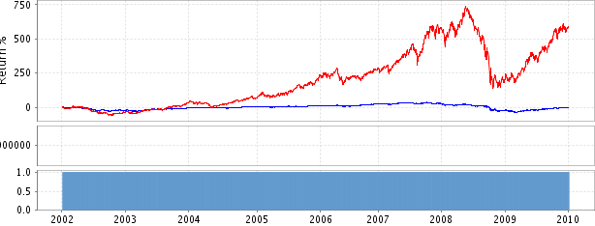 | 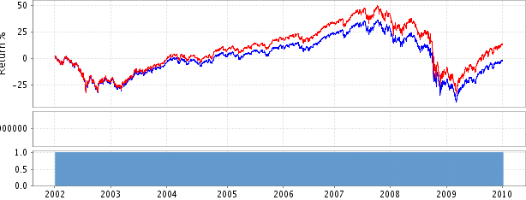 | 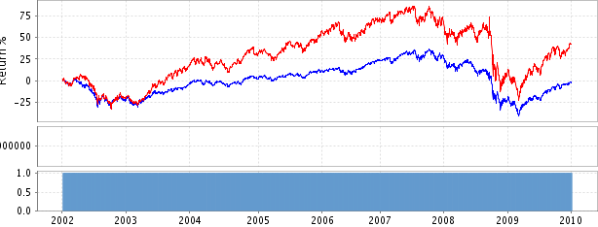
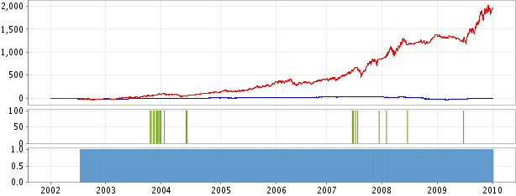 | 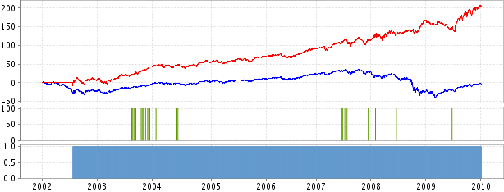 | 